Csc744 Homework 1 Answer

Fall 2008

Assigned on 09/03/2008

Due on 09/17/2008
Problem 1. (textbook 2.7) What are the major differences between message-passing and shared-address-space computers? Also outline the advantages and disadvantages of the two.
Ans: Please refer to the textbook section 2.3.2
Problem 2. (textbook 2.8) Why is it difficult to construct a true shared-memory computer? What is the minimum number of switches for connecting p processors to a shared memory with b words (where each word can be accessed independently)?
Ans: For a true shared-memory computer such as EREW PRAM with p processors and a shared memory with b words, each of the p processors in the ensemble can access any of the memory words, provided that a word is not accessed by more than one processor simultaneously. To ensure such connectivity, the total number of switches must be θ(pb). For a reasonable memory size, constructing a switching network of this complexity is very expensive. Thus a true shared-memory computer is impossible to realize in practice.
Problem 3. (textbook 2.9) Of the four PRAM models (EREW, CREW, ERCW, and CRCW), which model is the most powerful? Why?
Ans: CRCW PRAM is most powerful since this class allows multiple read and multiple write accesses to a common memory location.
Problem 4. (textbook 2.17) Determine the bisection width, diameter, and total number of switching nodes in √p×√p mesh.
Ans:
An N²-leaf 2d-MOT (N=√p) consists of N² nodes ordered as in a 2d-array N ×N (but without the links). The N rows and N columns of the 2d-MOT form N row CBTs(Complete Binary Tree) and N column CBTs respectively.
For such a network, total number of nodes is |V | = N²+2N(N −1), total number of edges is |E| = O(N²), the degree of graph is d = 3, the diameter of the graph is D = 4lgN=2lgp, the bisection width of the graph is bw = N=√p. The total number of switching nodes is 2N(N −1)=2√p(√p-1).
Problem 5 (textbook 5.2) Consider the search tree shown in Figure 5.10(a), in which the dark node represents the solution.
- If a sequential search of the tree is performed using the standard depth-first search (DFS) algorithm(section 11.2.1), how much time does it take to find the solution if traversing each ard of the tree takes one unit of time?
- Assume that the tree is partitioned between two processing elements that are assigned to do the search job, as shown in Figure 5.10(b). If both processing elements perform a DFS on their respective halves of the tree, how much time does it take for the solution to be found? What is the speedup? Is there a speedup anomaly? If so, can you explain the anomaly?
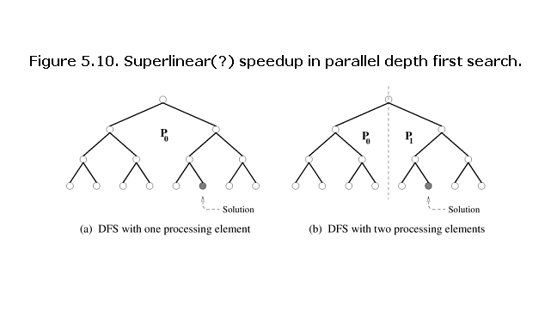
Ans:
- If a sequential search of the tree is performed using the standard depth-first search (DFS) algorithm, 11 edges need to be traversed to access the dark node. If traversing each arc of the tree takes one unit of time, then the running time is 11.
- If both processing elements perform a DFS on their respective halves of the tree, the running time is 4 to find the dark node.
By the definition of speedup, we have speedup=Ts/Tp=11/4=2.75 which is greater than the number of processors 2. There is a speedup anomaly. This is called superlinearity effects due to exploratory decomposition. The cause for this superlinearity is that the work performed by parallel and serial algorithms is different.

