Assignment 2

Due on Tuesday, March 24, 2025

1. Complete the parallel pseudocode given in the following divide-and-conquer method for all eight processors.

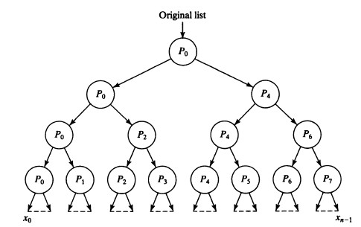

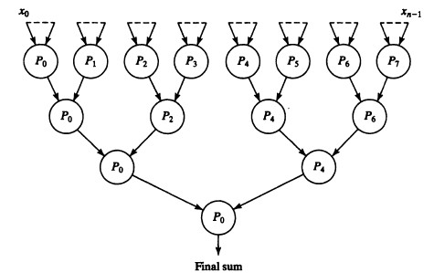

2. Develop a divide-and-conquer algorithm that finds the smallest value in a set of *n* values in O(log*n*) steps using *n*/2 processors. What is the time complexity?

3. Design an algorithm to find the sum of *n* numbers in parallel using 2-D mesh interconnection work (Assume *p* processors are available, and the original list is on Processor 0). Write the pseudocode, and then analyze the execution time (including communication time and computation time), and calculate the speedup. Please draw the picture to explain the algorithm as well if you think it is necessary.

4. Assume a sequence of 18 integers 11, 29, 21, 4, 43, 24, 52, 8, 17, 50, 45, 30, 15, 34, 54, 2, 35, 61. Write the detailed steps to sort the integers using bucket sorting (3 buckets with equal size). If there are three processors available, write the detailed steps to sort them using the parallel bucket sorting algorithm (further parallelization version) described in the textbook.