# MPI Lab 1 Part II

# Print out “Hello World from process xxx of total xxx!”

1. Revise your program as *hello_node.c*, in which two variables *nprocs* and *mypid* are declared and will hold the value of total number of processes and identifier of calling process respectively. Then print out “Hello world from process xxx of total xxx!” What functions do you use to find the value for *nprocs* and *mypid*?

2. Compile your program using the following command:

*mpicc hello_node.c -o hello_node*

3. Run the program using the following command.

*mpirun -np 8 ./hello_node*

4. You should have the following output:

Hello World from process 0 of total 8!

Hello World from process 7 of total 8!

Hello World from process 5 of total 8!

Hello World from process 2 of total 8!

Hello World from process 1 of total 8!

Hello World from process 3 of total 8!

Hello World from process 4 of total 8!

Hello World from process 6 of total 8!

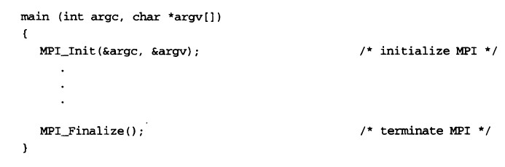

MPI_Comm_rank (MPI_COMM_WORLD, &rank); /* get current process id */

MPI_Comm_size (MPI_COMM_WORLD, &size); /* get number of processes */