Lab 4 Find the Parallel Sum Using Divide and Conquer

1. Assume there are 8 processing nodes and there are 256 numbers (1, 2,..., 256) to be added. The original list is initialized at processor 0, and then is divided into two halves to broadcast level by level until the leaves are reached as shown below (each processor will have 256/8=32 numbers).
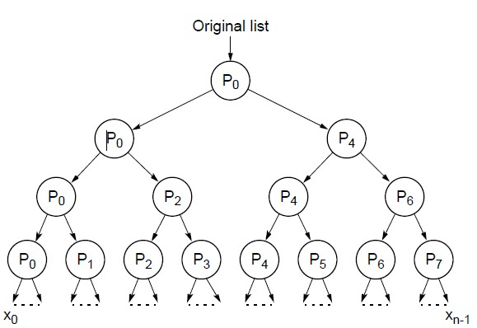
After each processor receives its final sublist (32 numbers), it calculates its partial sum. The partial sums will be reduced level by level as shown below. The final sum will be obtained and printed out on processor 0.
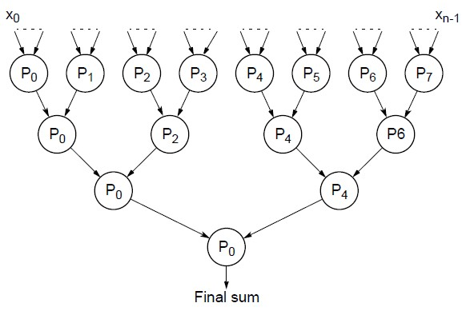

You should have the following contents:

Processor 0 sends sublist to processor 4 at level 1
Processor 0 sends sublist to processor 2 at level 2
Processor 0 sends sublist to processor 1 at level 3
The partial sum on processor 0 is 528
Processor 1 receives sublist from processor 0 at level 3
The partial sum on processor 1 is 1552
Processor 1 sends sublist to processor 0 at level 0
Processor 2 receives sublist from processor 0 at level 2
Processor 2 sends sublist to processor 3 at level 3
The partial sum on processor 2 is 2576
Processor 4 receives sublist from processor 0 at level 1
Processor 4 sends sublist to processor 6 at level 2
Processor 4 sends sublist to processor 5 at level 3
The partial sum on processor 4 is 4624
Processor 6 receives sublist from processor 4 at level 2
Processor 6 sends sublist to processor 7 at level 3
The partial sum on processor 6 is 6672
Processor 4 receives sublist from processor 5 at level 3
Processor 0 receives sublist from processor 1 at level 3
Processor 5 receives sublist from processor 4 at level 3
The partial sum on processor 5 is 5648
Processor 5 sends sublist to processor 4 at level 0
Processor 4 receives sublist from processor 6 at level 2
Processor 4 sends sublist to processor 0 at level 2
Processor 6 receives sublist from processor 7 at level 3
Processor 6 sends sublist to processor 4 at level 1
Processor 7 receives sublist from processor 6 at level 3
The partial sum on processor 7 is 7696
Processor 7 sends sublist to processor 6 at level 0
Processor 3 receives sublist from processor 2 at level 3
The partial sum on processor 3 is 3600
Processor 3 sends sublist to processor 2 at level 0
Processor 2 receives sublist from processor 3 at level 3
Processor 2 sends sublist to processor 0 at level 1
Processor 0 receives sublist from processor 2 at level 2
Processor 0 receives sublist from processor 4 at level 1
The final sum is 32896

2. Revise your program and script file accordingly so that your program is working for 16 nodes, and then run your program.

