CSI

Computer Science Dept.

ODG

**Download and Install Visual Studio from Imagine X (MSDNAA)**

1. First Register by following the procedure:

<http://www.cs.csi.cuny.edu/?content=elms-procs>

1. Then Login at ([www.cs.csi.cuny.edu](http://www.cs.csi.cuny.edu), MSDNAA):

https://e5.onthehub.com/WebStore/Welcome.aspx?ws=35c5d7a8-ce9b-e011-969d-0030487d8897

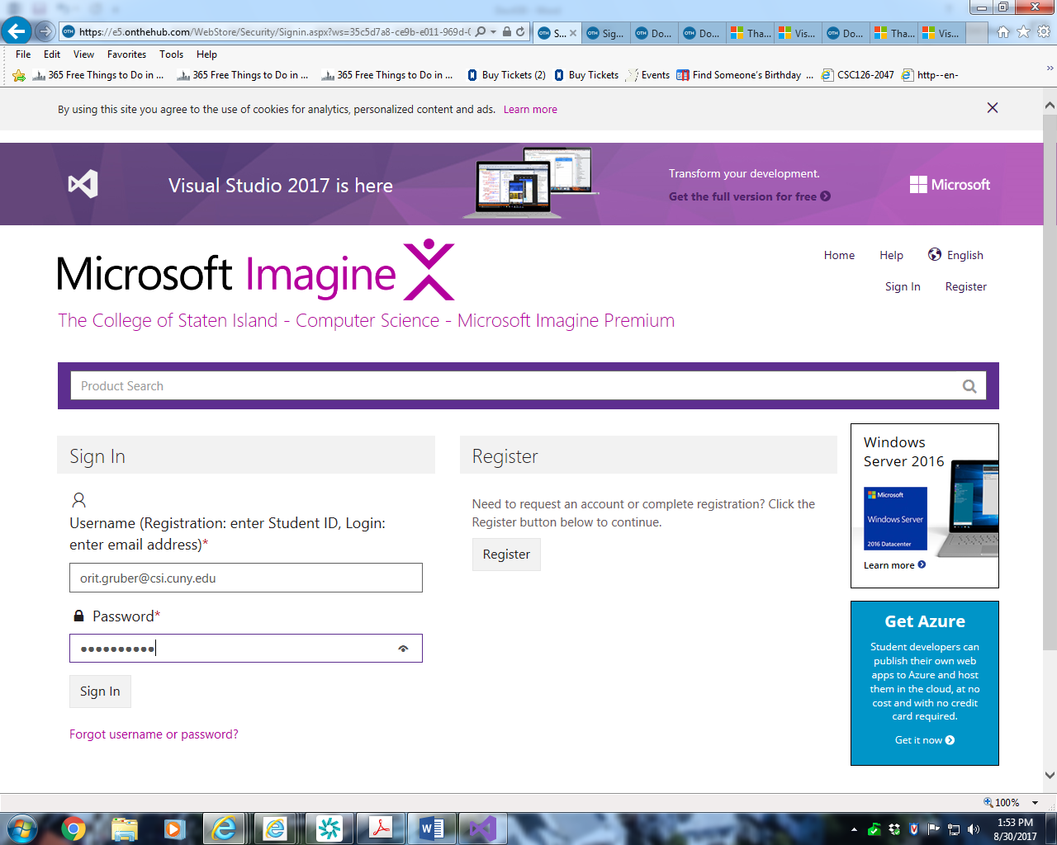

Log In with the email you used during Registration.

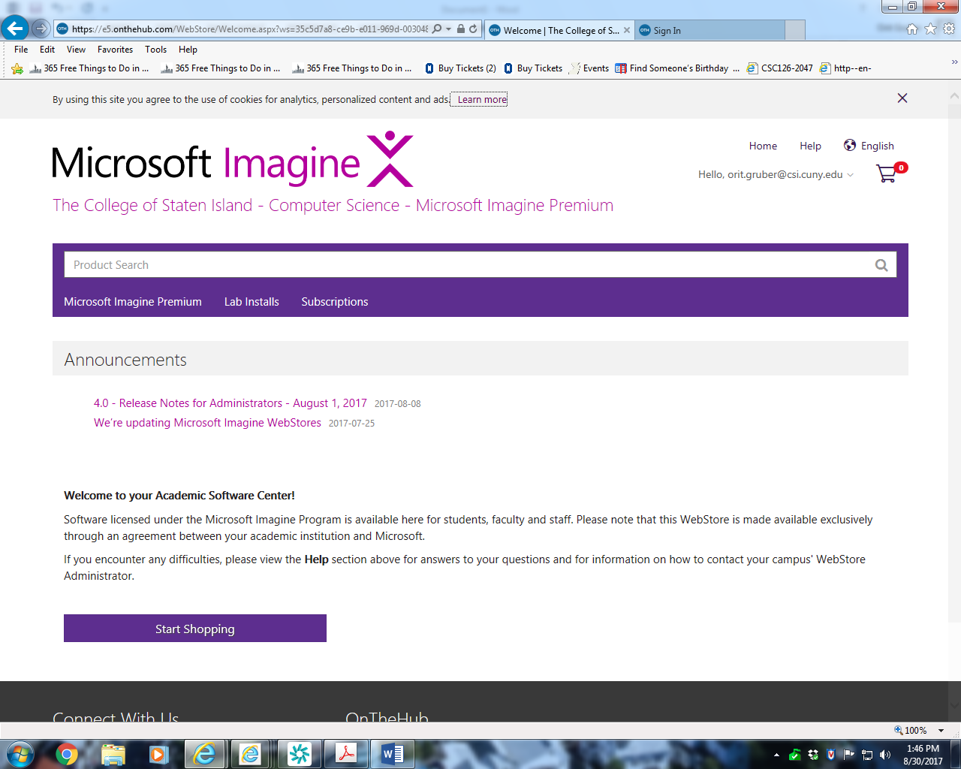

Select “Start Shopping”

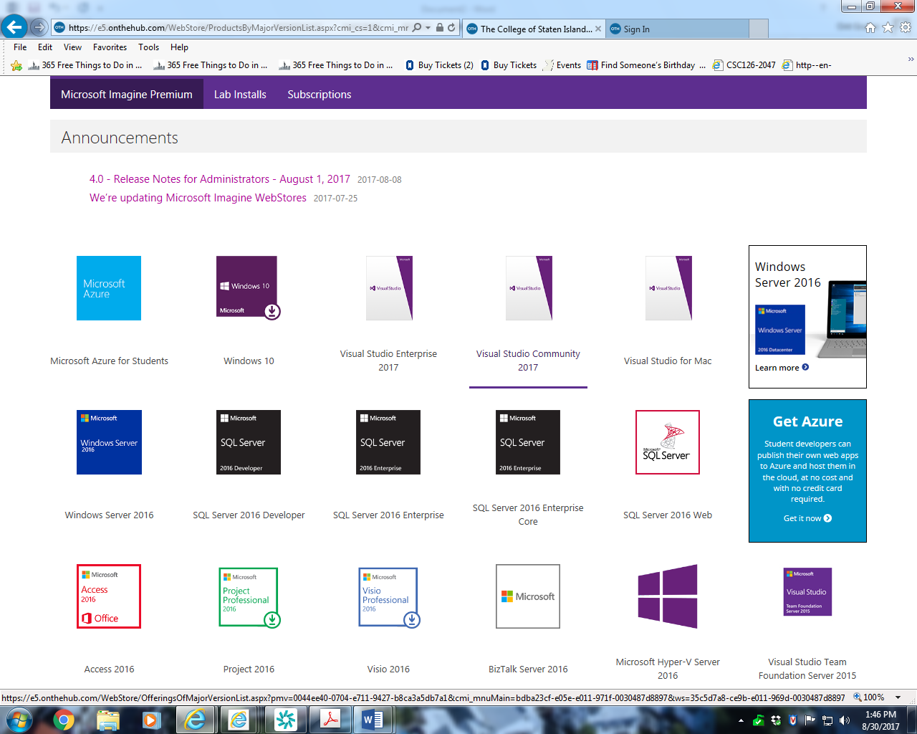

Select “Visual Studio Community 2017”

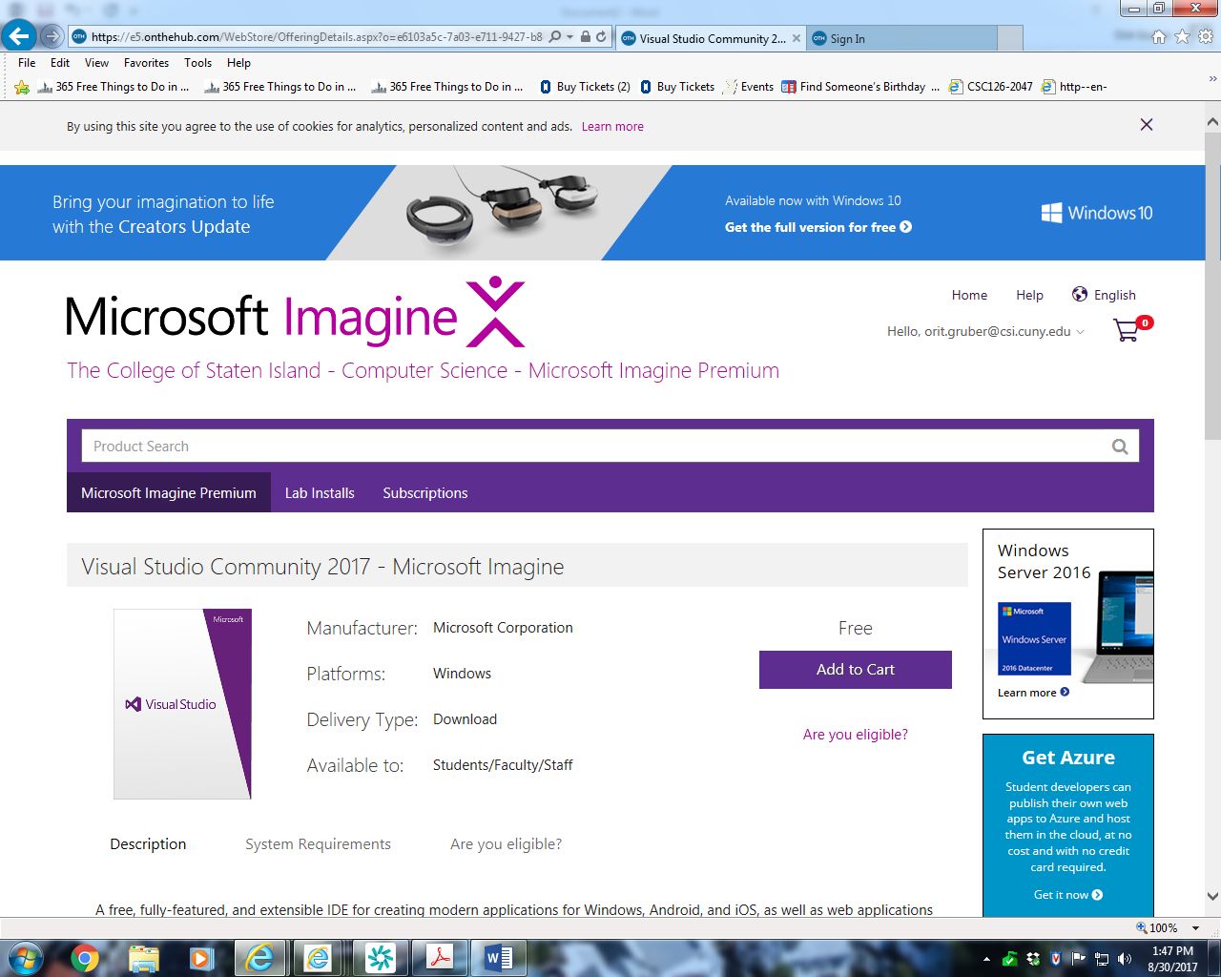

Select “Add to Cart”

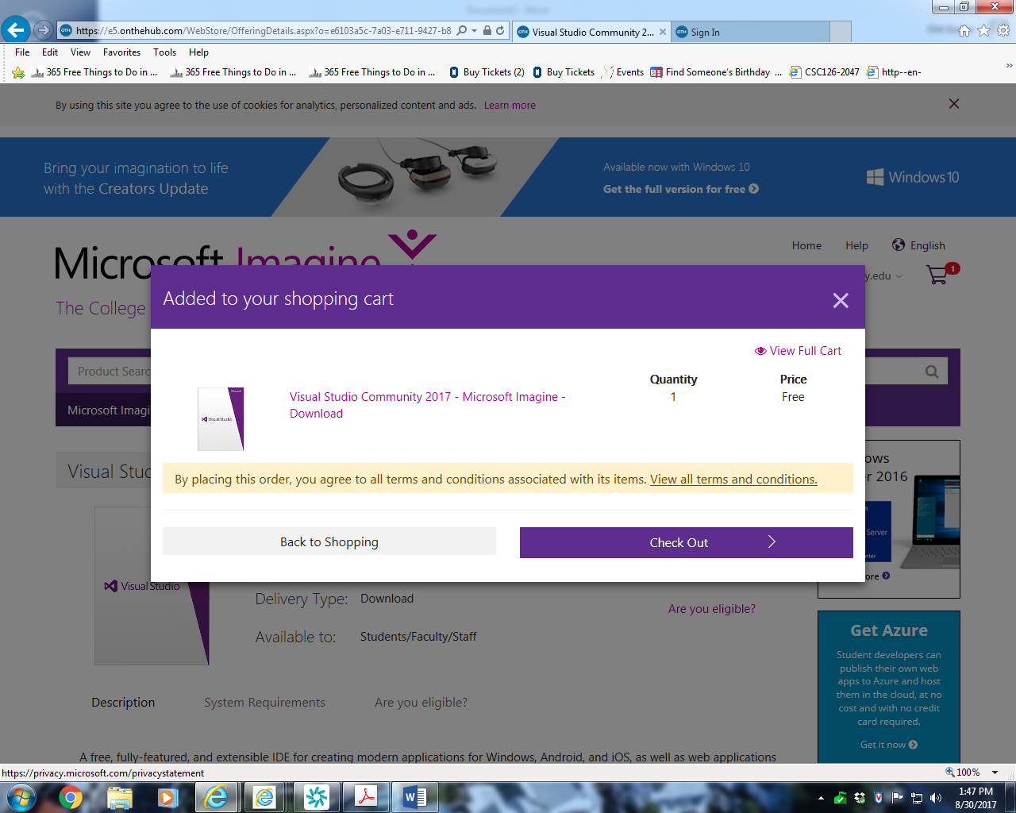

Select ‘Check Out”

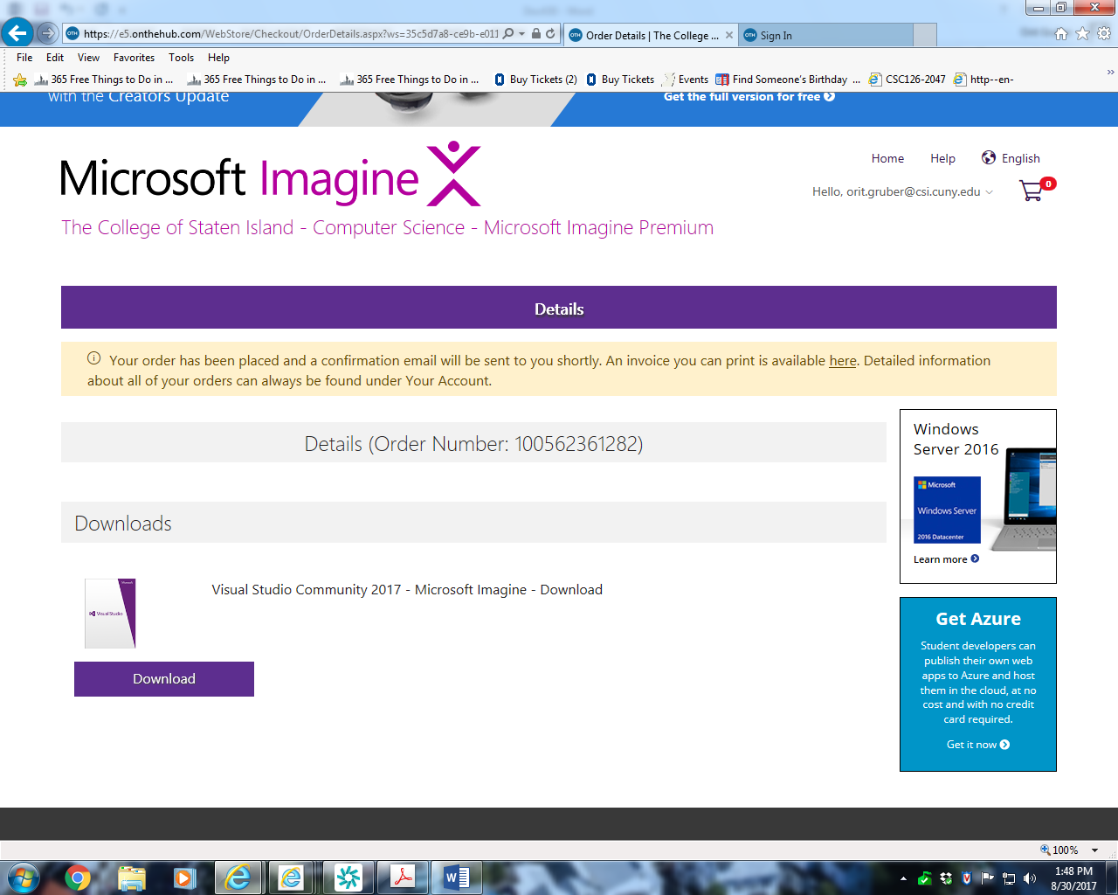

Select “Download”

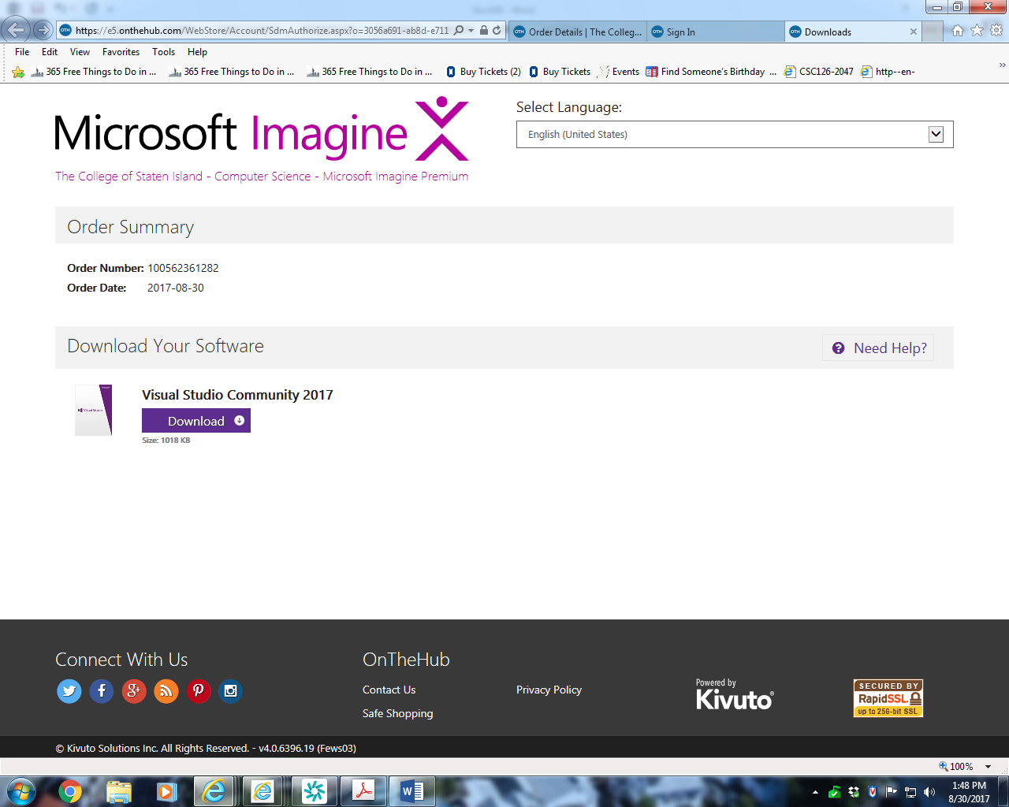

Select “Download”

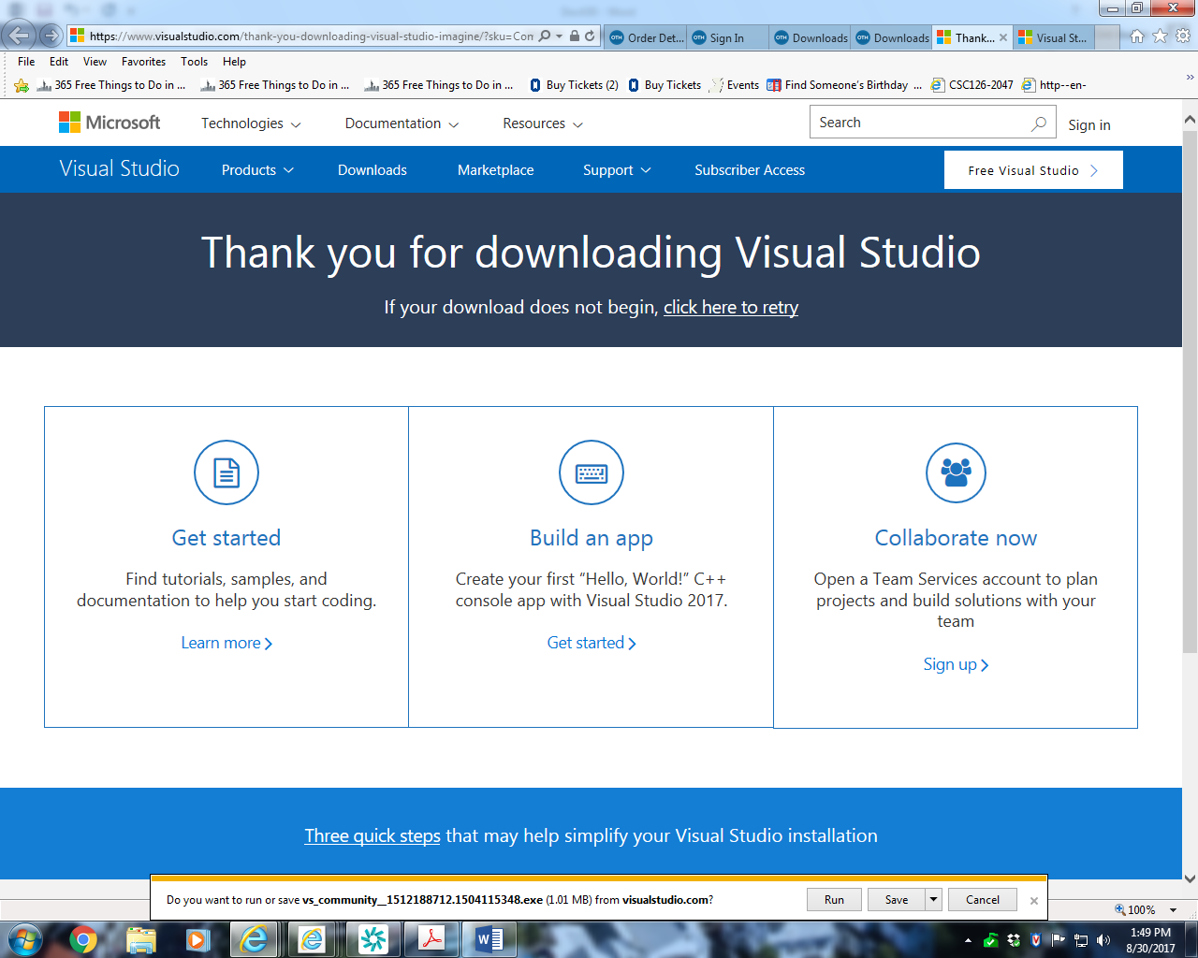

Select “Run”

CSI

CS Dept

ODG

**Recommended Selections during VS 2017 C++ Installation**

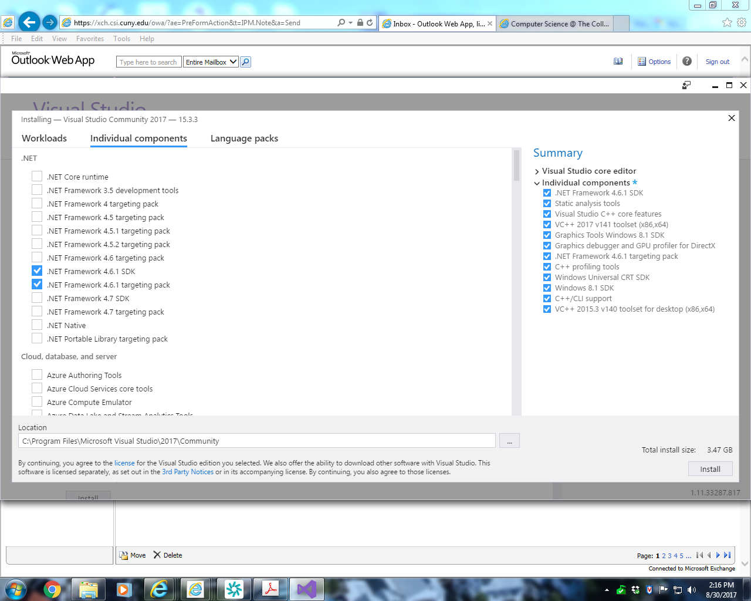

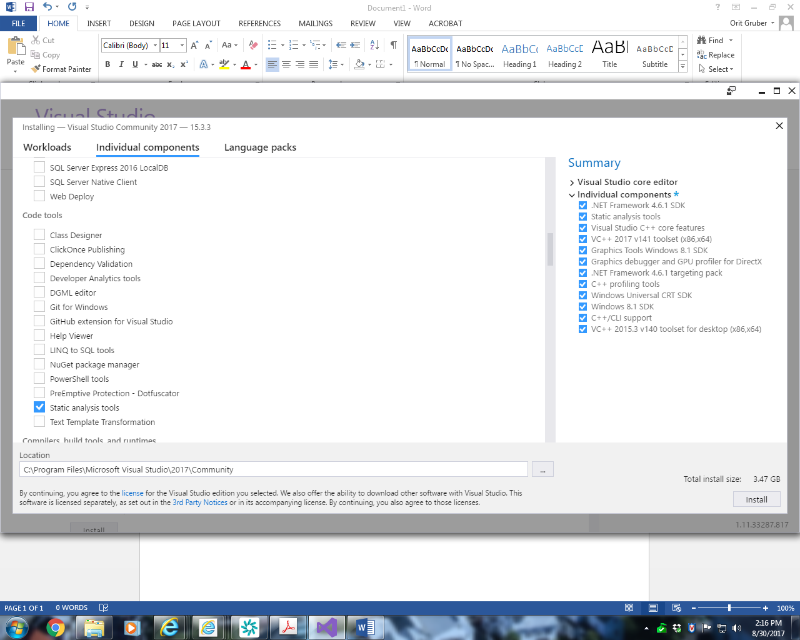

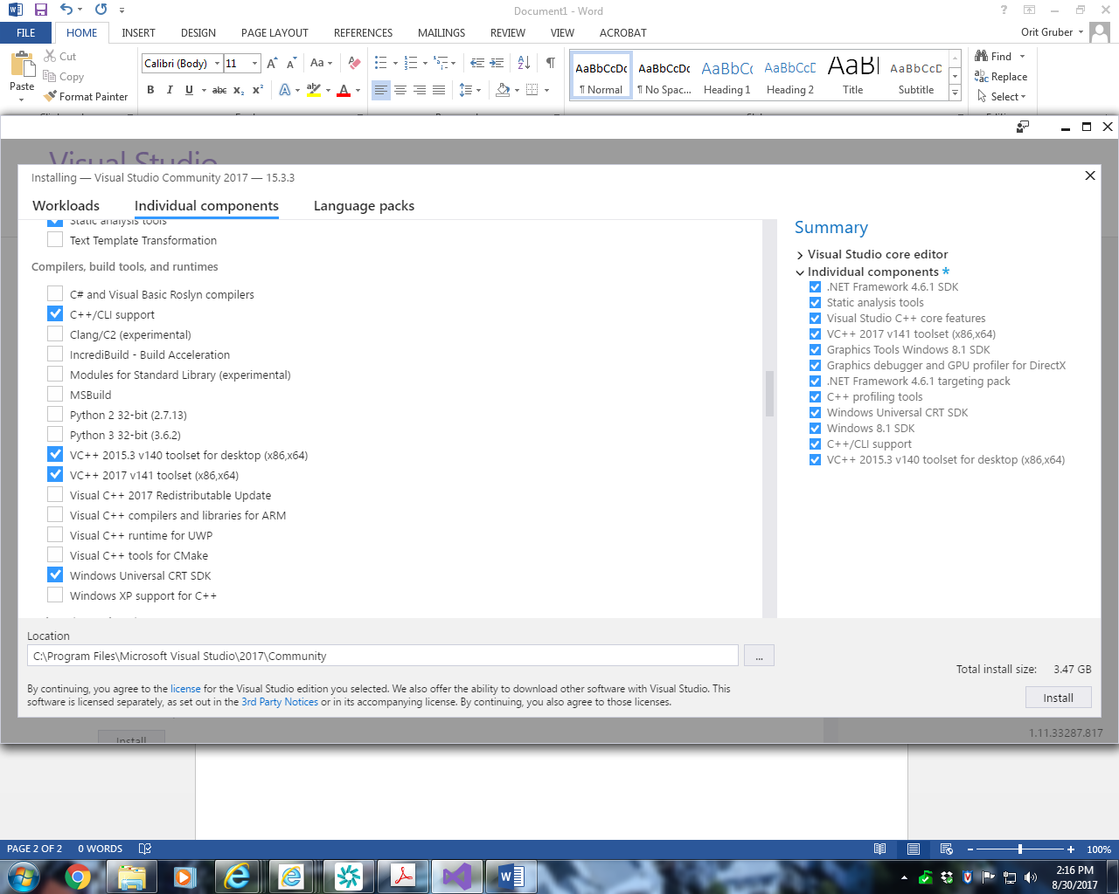

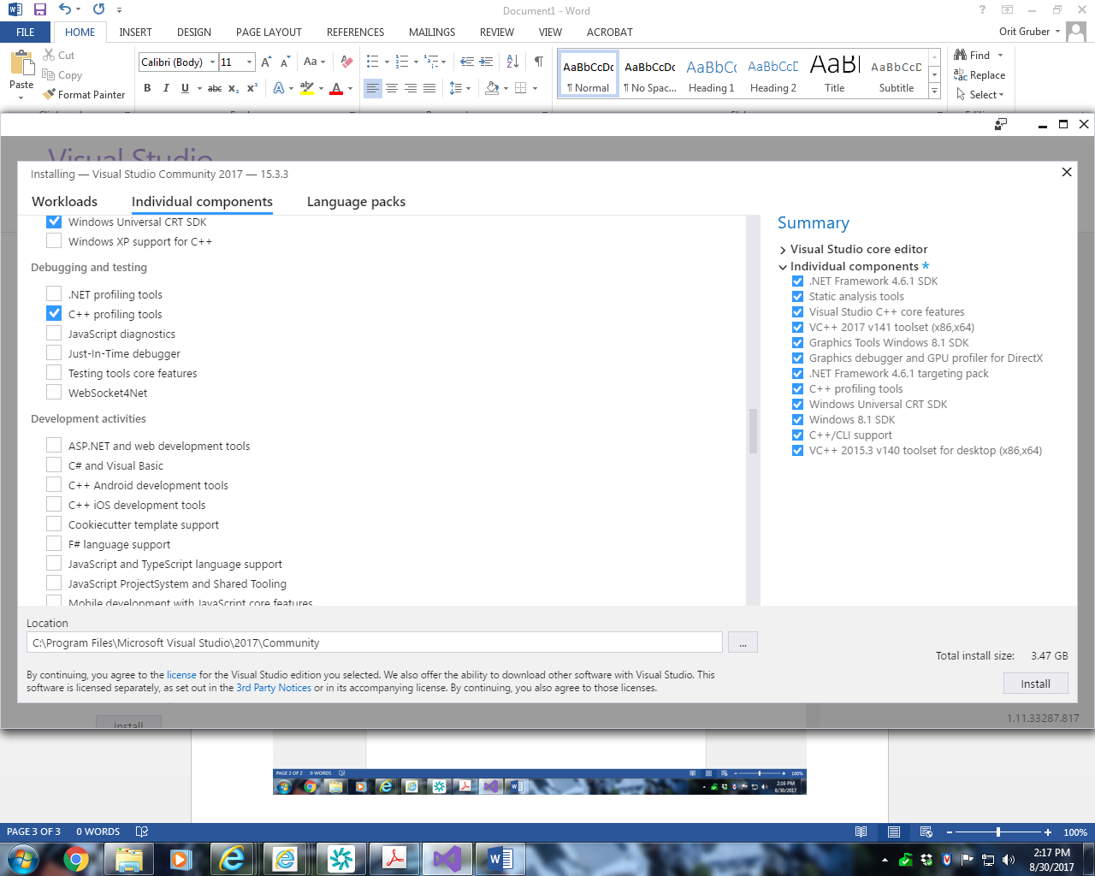

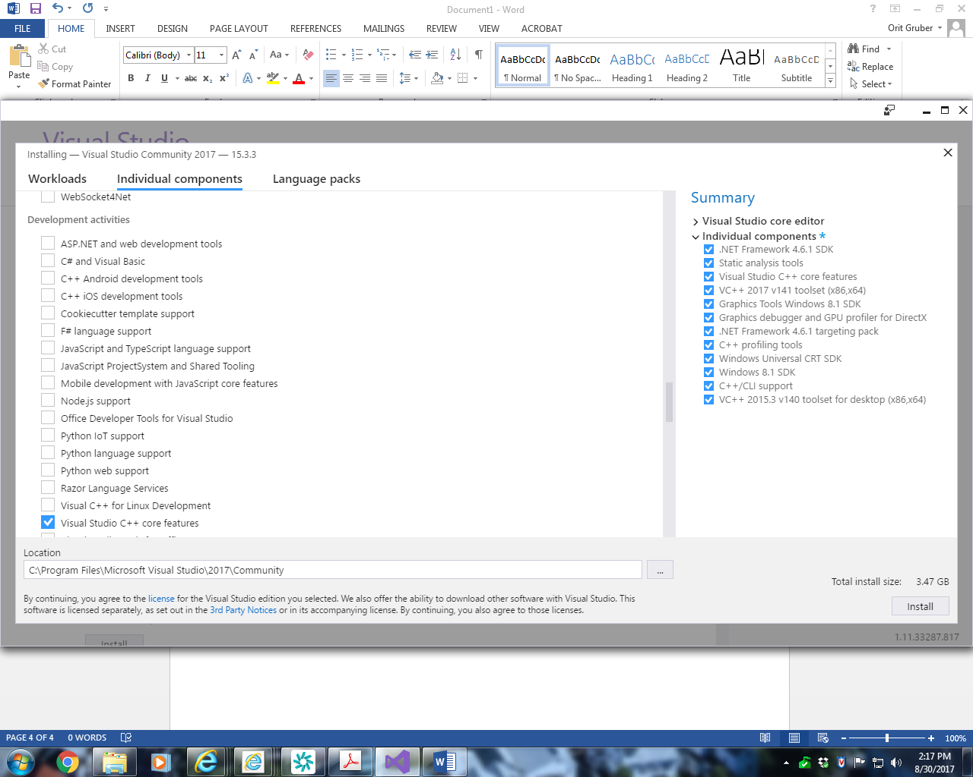

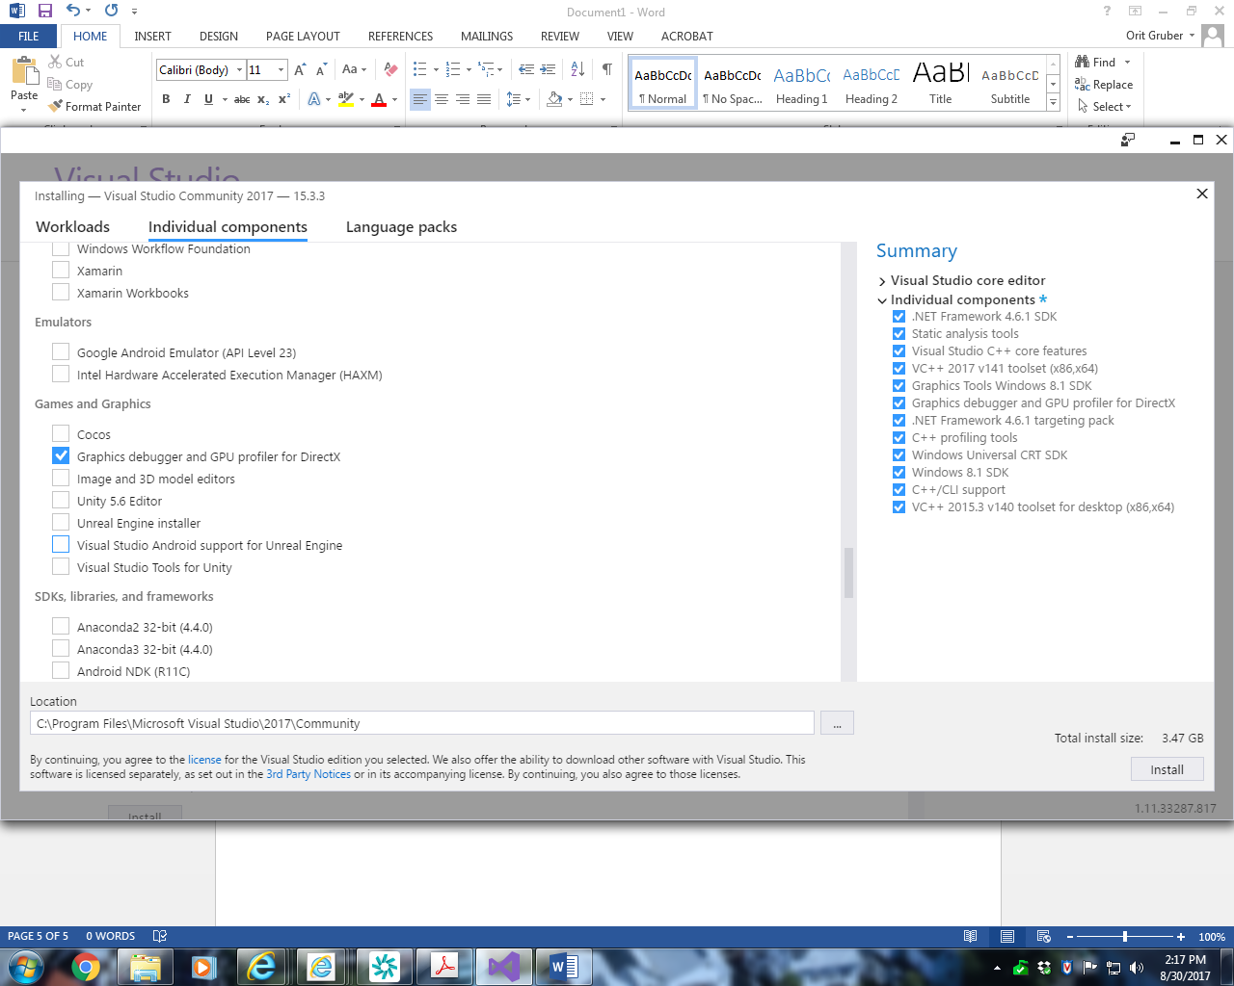

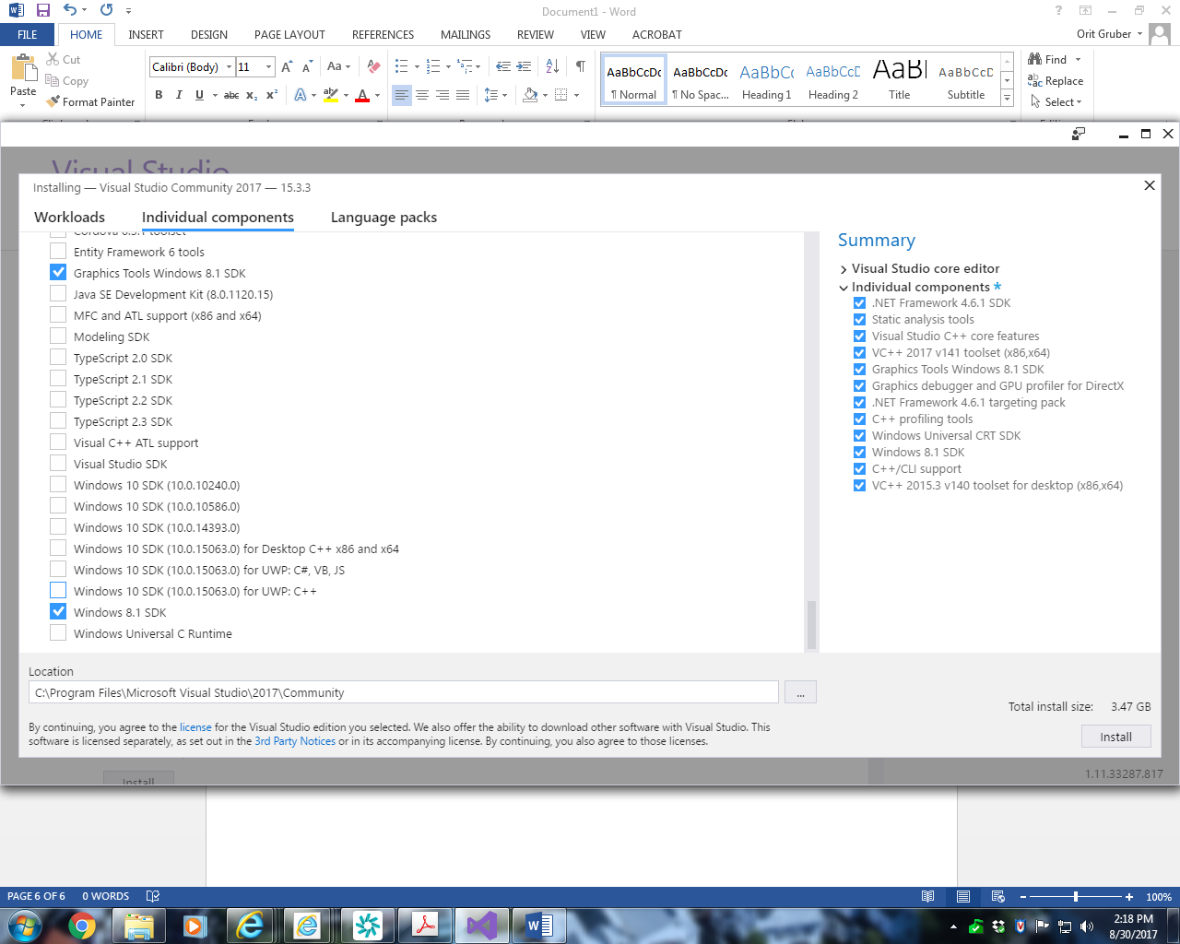

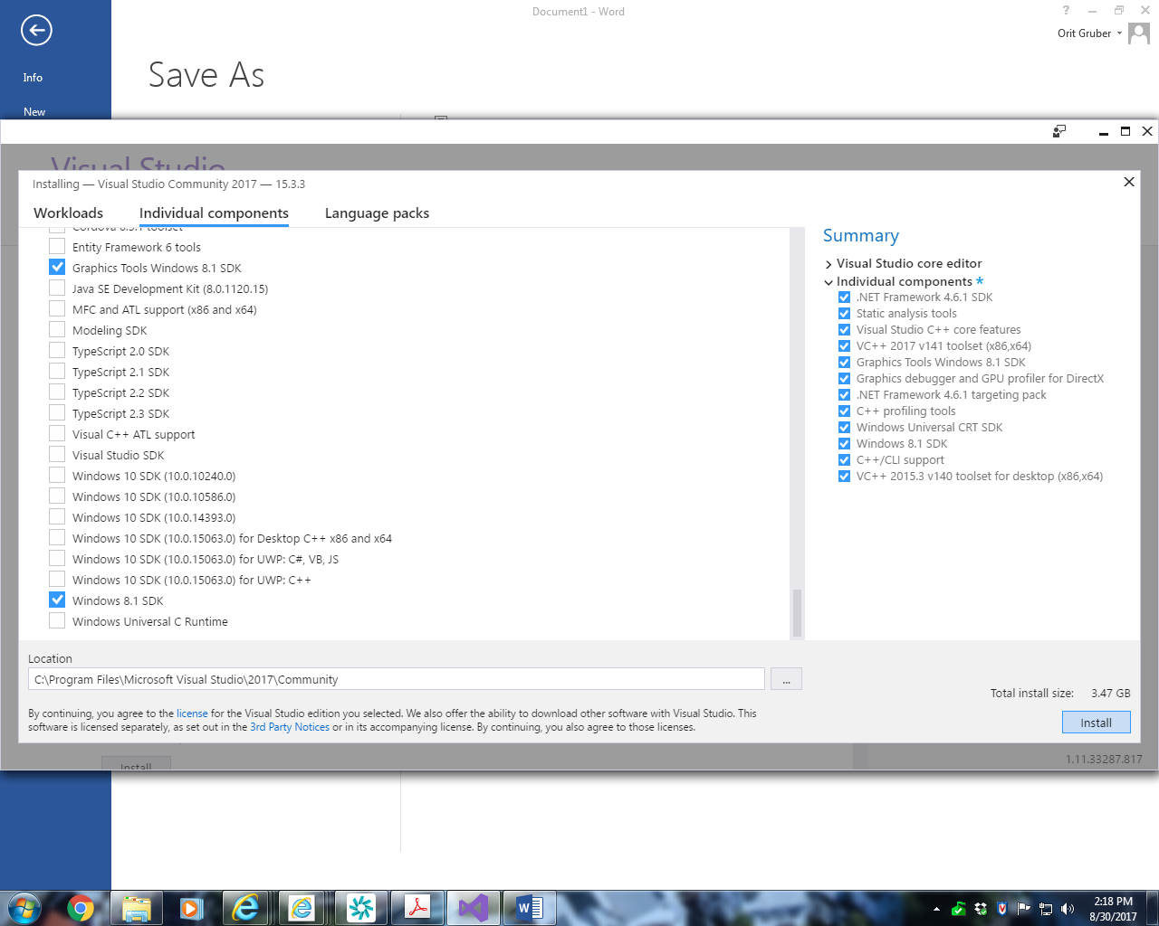

Select “Install”

Build Your First C++ Program

https://tutorials.visualstudio.com/cpp-console/intro.html